Analyzing Game Sales Across Regions and Platforms
To convert Excel file into CSV and create a database using USE keyword named as Game and go-to table import csv file from desktop.
Task 1:
Insert a new game with the title "Future Racing", genre "Racing", release date
"2024-10-01", and developer "Speed Studios".
Query:
Insert into games(GameTitle,Genre,ReleaseDate,Developer) values("Future Racing","Racing","10-01-2024","Speed Studios");
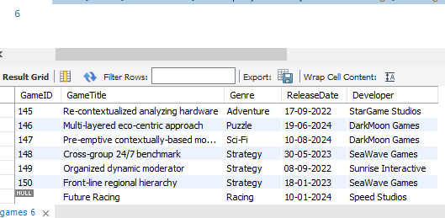
Task 2:
Update the price of the game with GameID 2 on the PlayStation platform to 60.
Query:
Update game_sales set Price=60.00 where GameID=2;
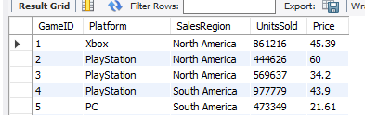
TASK 3:
Delete the record of the game with GameID 5 from the Game Sales table.
Query:
Delete from game_sales where GameID=5;
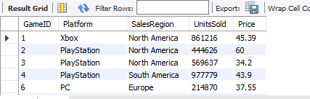
TASK 4:
Calculate the total number of units sold for each game across all platforms and
regions.
Query:
Select Platform,SalesRegion,count(Unitssold) from game_sales group by Platform,SalesRegion;
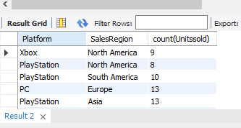
TASK 5:
Identify the game with the highest number of units sold in North America.
Query:
select GameID,Unitssold,SalesRegion from game_sales where SalesRegion="North America" order by Unitssold desc limit 1;
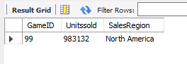
Task 6:
Get the game titles, platforms, and sales regions along with the units sold for each
game.
Query:
Select G.GameTitle,S.Platform,S.SalesRegion,S.Unitssold from Games G inner join Game_sales S on G.GameID=S.GameID;
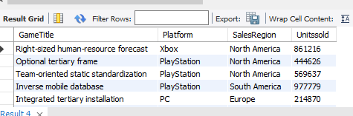

Task 7:
Find all games, including those that have no sales data in the Game Sales table.
Query:
Select * from games g left join game_sales s on g.GameID=s.GameID;
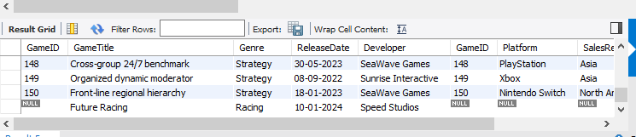
TASK 8:
Retrieve sales records where the game details are missing in the Games table
Query:
Select * from games g Right join game_sales s on g.GameID=s.GameID;
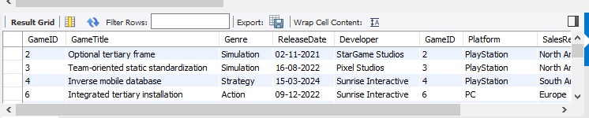

Task 9:
Retrieve game sales data for North America and Europe removing duplicate
Records
Query:
Select distinct GameID,SalesRegion from Game_sales where SalesRegion="North America" and SalesRegion="Europe";
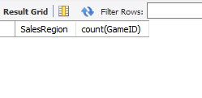
TASK 10:
Retrieve all game sales data from North America and Europe without removing
duplicate records.
Query:
Select GameID,SalesRegion from Game_sales where SalesRegion IN("North America","Europe");
